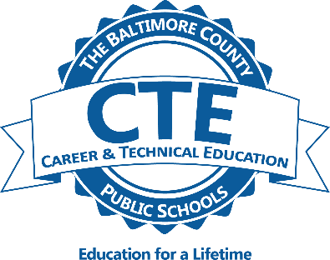 

**Construction & Development:**

**Carpentry & Pathways to Skilled Trades**

MC900310856[1]

### Students in the carpentry careers program acquire information and experience related to residential and commercial construction. Safety, hand and power tools, leveling instruction, foundation layout, floor and wall construction, roof construction, blueprint reading, forming, and job estimating are units of instruction emphasized for carpentry students.

### 

### Carpentry students will complete the National Center for Construction Education and Research (NCCER) Core Learning and Carpentry Level One certification exams.

### 

### Students completing the program successfully are eligible for advanced placement in first year apprenticeship in the Associated Builders and Contractors (ABC) Apprenticeship Program.

### 

### They may also be eligible for advanced placement and/or testing opportunities through other union or non-union apprenticeship programs and/or receive college credit at a postsecondary institution through an articulation agreement with CCBC.

**Carpentry Capstone Work Experience**

*CWE may be available to students in their junior or senior year.